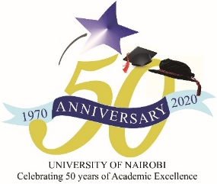

COLLEGE OF BIOLOGICAL AND PHYSICAL SCIENCES
DEPARTMENT OF METEOROLOGY
UON@50 CELEBRATIONS
THEME: THE SCIENCE OF METEOROLOGY: ITS EVOLUTION AND CENTRALITY TO LIVELIHOODS, SOCIO-ECONOMICS, AND SUSTAINABLE DEVELOPMENT
SUBTHEME: ADVANCES IN METEOROLOGICAL TRAINING AND RESEARCH
Date: Wednesday 16 June 2021 | Time: 15:00 EAT | Venue: Virtual via Zoom
TIME (EAT) | ACTIVITY | IN CHARGE
14:45-15:00 | Logging in by guests | ICT Team
15:00 – 15:05 | Anthems (National, EAC, UoN) | ICT Team
15:05 – 15:10 | Welcome and Introduction | Moderator: Cromwel Lukorito. Lecturer, Dept of Meteorology
15:10 – 15:20 | Chairman’s address | Franklin J. Opijah,  Chairman, Department of Meteorology
15:20 – 15:35 | Topic: Opportunities and Threats to Meteorological Education and Research in Kenya  Presenter: Prof Francis Mutua, University of Nairobi | Moderator: Cromwel Lukorito, Department of Meteorology
15:35 – 15:50 | Topic: Meteorological Research in Kenya: Prospects and Lessons  Presenter: Prof Silvery S.B. Otengi, Masinde Muliro University of Science and Technology | Moderator: Cromwel Lukorito, Department of Meteorology
15:50 – 16:15 | Topic: Evolution and Prospects of the Science of Meteorology  Presenter: Prof Fredrick Semazzi, North Carolina State University | Moderator: Cromwel Lukorito, Department of Meteorology
16:15 – 16:45 | Q&A interactive session | Moderator: Cromwel Lukorito, Department of Meteorology
16:45 – 17:00 | Vote of thanks and closure | Prof. Alfred Opere, Dept of Meteorology
Register in Advance for the meeting: Zoom link

