UNIVERSITY OF NAIROBI
COLLEGE OF BIOLOGICAL AND PHYSICAL SCIENCES
SCHOOL OF PHYSICAL SCIENCES

DEPARTMENT OF CHEMISTRY

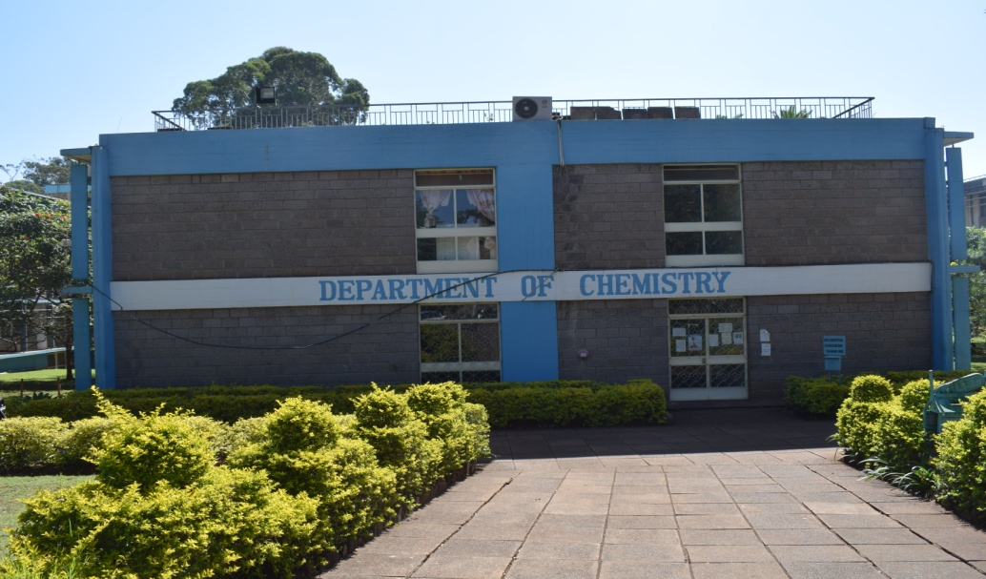
Dept. of Chemistry Building

ANNUAL REPORT

2020

Compiled and edited by:
Prof David Kariuki
Ag. Chairman, Department of Chemistry
http://chemistry.uonbi.ac.ke/

1.0 INTRODUCTION
The Department of Chemistry is located in Chiromo Campus, Off-Riverside Drive. It is part of the School of Physical Sciences, College of Biological and Physical Sciences. The department has over 1000 students’ comprising of PhD, MSc and undergraduate including servicing the School of Pharmacy, Engineering, Agriculture and Education
In the 2019/2020 academic year the Department handled about 700 BSc undergraduates and BSc ODL (Analytical and Industrial Chemistry 46, MSc 34 and 7 PhD. students. In addition, we handled a total of about 603 students from other schools and faculties, which includes College of Architecture and Engineering (Civil, Mechanical and Bio Systems Engineering), College of Agriculture and Veterinary Services (Agriculture and Veterinary Medicine), College of Health Sciences (Pharmacy) and College of Education & External Studies CEES (Kenya Science Campus). These students were served by 70 staff. In this period, we offered 3 undergraduate and4 postgraduate programs.
Prof John M. Onyari is the Chairman of the Department of Chemistry since August 17, 2015.
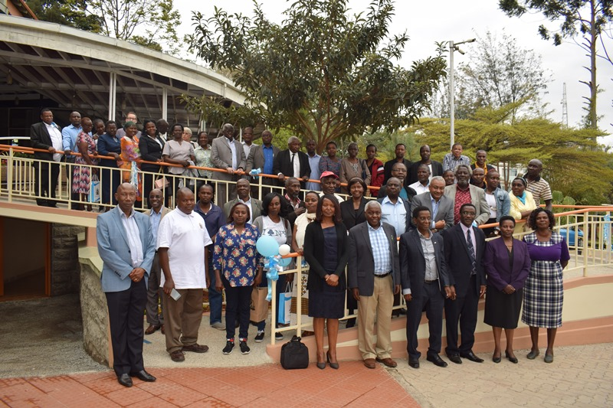
Dept. of Chemistry Group photo

STAFF ESTABLISHMENT DECEMBER, 2019
Academic Staff

Professors
Prof. J.O. Midiwo
Prof. I. O. Jumba
Prof. D.O. Orata
Prof. Abiy Yenesew
Associate Professor
Prof. B. Bhatt
Prof. L.W. Njenga
Prof. J.M. Onyari
Prof. H. N. Njenga
Prof. A.O. Yusuf
Prof. J.P. Kithinji
Prof. D.K. Kariuki-
Prof. L. Kerubo Omosa

Senior Lecturers
Dr. W.A Odinga
Dr. J.M. Mwaniki
Dr. Solomon Derese
Dr. J.M. Wanjohi
Dr. J.A. Ndakala
Dr. F. D. Oduor
Dr. P.M. Guto
Dr. D.W. Mbui
Dr. Immaculate Michira

Lecturers
Dr. B. Wamalwa
Dr. D.A. Abong’o
Dr. John Onyatta
Dr. J. N. Wabomba
Dr. Njagi Njomo
Dr. Vincent Madadi
Dr. Joyce G. Njagi-Kithure
Dr. Marina Mukabi
Dr. Beth Ndunda
Dr. Patrick Tum
Dr. G. Bosire
Dr Ruth A. Odhiambo
Dr.. J.M. Makopa
Mr. C.W. Mirikau
Mr. G. Wafula
Tutorial Fellows
Ms. Immaculate A. Odero
Dr. Fredreck M. Mwazighe
Dr. Racheal N. Njogu
1.1Number of Staff and their Designations
Professor | 4
Associate Professor | 8
Senior Lecturers | 9
Lecturers | 15
Tutorial Fellows | 3
Principal Technologist | 1
Chief Technologist | 1
Assistant Chief Technologist | 2
Senior Technologist DEF | 8
Technologist ABC | 9
Technical Assistant II | 1
Document list | 1
Senior Administrative Assistant | 1
Secretary | 1
TOTAL | 41

1.2 PROGRAMMES OFFERED AND SERVICES OFFERED
The Department has over 1000 students’ comprising of PhD, MSc and undergraduate including servicing the Schools of Pharmacy, Engineering, Agriculture and Education.
The Department offers the following undergraduate and postgraduate degree programs:
Undergraduate Programs
B.Sc. in Industrial Chemistry
B.Sc in Chemistry
BSc in Analytical Chemistry
Postgraduate Programs
MSc in Chemistry
MSc in Environmental Chemistry

MSc. in Analytical Chemistry
MSc Industrial chemistry
PhD (Chemistry)
Doctor of Philosophy in Chemistry.

1.3 NUMBER OF STUDENTS ENROLLED IN UNDERGRADUATE AND POSTGRADUATE PROGRAMMES 2019
1.3.1 Undergraduate program Enrolment
Programme | Female | Male | Nos of students | Total
Bachelor of Science in Chemistry | 77 | 38 | 115 | 230
Bachelor of Science (Industrial Chemistry) | 52 | 19 | 71
Bachelor of Science (Analytical Chemistry) | 27 | 17 | 44
1.3.2 Postgraduate program enrolment
1.3.2.1 Master of Science (MSc)

Programme | Female | Male | No of students | Total
MSc (Environmental Chemistry) | 8 | 2 | 10 | 27
MSc (Analytical Chemistry) | 6 | 2 | 8
MSc (Chemistry) | 8 | 1 | 9
MSc(Industrial Chemistry)
1.3.2.2 Doctor of Philosophy in Chemistry (PhD)
Programs | Female | Male | Nos of students | Total
PhD (Environmental Chemistry)  PhD (Chemistry) | 1  2 | 0  0 | 1  2 | 3

1.4 INTERNATIONAL STUDENTS
The Department hosts a number of international students undertaking postgraduate programs. They were as follows:

S/No | NAMES OF INTERNATIONAL STUDENTS & STAFF | REG. NUMBER | COUNTRY | DOCUMENTATION*
1 | ANDIMA MOSES | I80/50060/2015 | UGANDA | SMIS LIST
2 | OWOR RICHARD ORIKO | I80/50120/2015 | UGANDA | SMIS LIST
3 | NCHIOZEM-NGNITEDEM ALEXE | I80/52552/2018 | CAMEROON | SMIS LIST
4 | BUYINZA DANIEL | I80/96687/2014 | UGANDA | SMIS LIST
5 | ADEM FOZIA ALI | I80/97548/2015 | ETHIOPIA | SMIS LIST
6 | KYOMUHIMBO HILDA DINAH | I56/83188/2015 | UGANDA | SMIS LIST
7 | KAMYA VICENT | I56/7376/2017 | UGANDA | SMIS LIST
8 | CHILIKWAZI BRIGHT | I56/7376/2017 | ZAMBIA | SMIS LIST
9 | ACHUOTH MACH PAUL | I5689425/2016 | SOUTH SUDAN | SMIS LIST
10 | OZIOKO UCHENNA SANDRA | I56/11843/2018 | NIGERIA | SMIS LIST
11 | MAKANI RACHEAL BUNGISHABAKU | I56/11841/2018 | CONGO | SMIS LIST
12 | NAMANYA LOYCE | I56/11843/2018 | UGANDA | SMIS LIST
13 | RUGIMBANA CLAUDE | I56/5767/2017 | RWANDA | SMIS LIST
14 | IBRAHIM HASHIM | I80/54101/2019 | NIGERIA | SMIS LIST

2.0 STRATEGIC ISSUES
2.1RESEARCH FACILITIES IN THE DEPARTMENT
The department conducted trainings and provided consultancy services to various clients from both Public and Private sectors. The major clients included Pest Control Products Board, KEWI, Nation Media, various Universities on application of GC/MS, HPLC, FTIR, AAS, UV/Visible, as well as emissions measurements etc.

THE DEPARTMENT OF CHEMISTRY HAS ACQUIRED MAGRITEK SPINSOLVE 60 NMR, SPECTROMETER

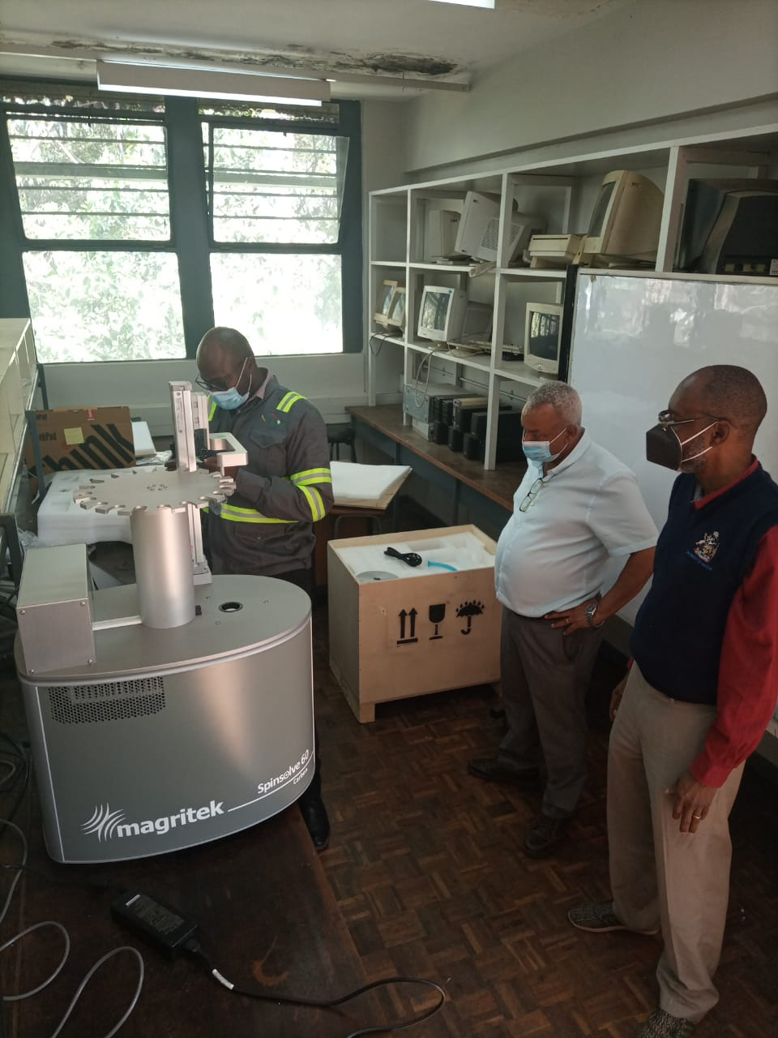

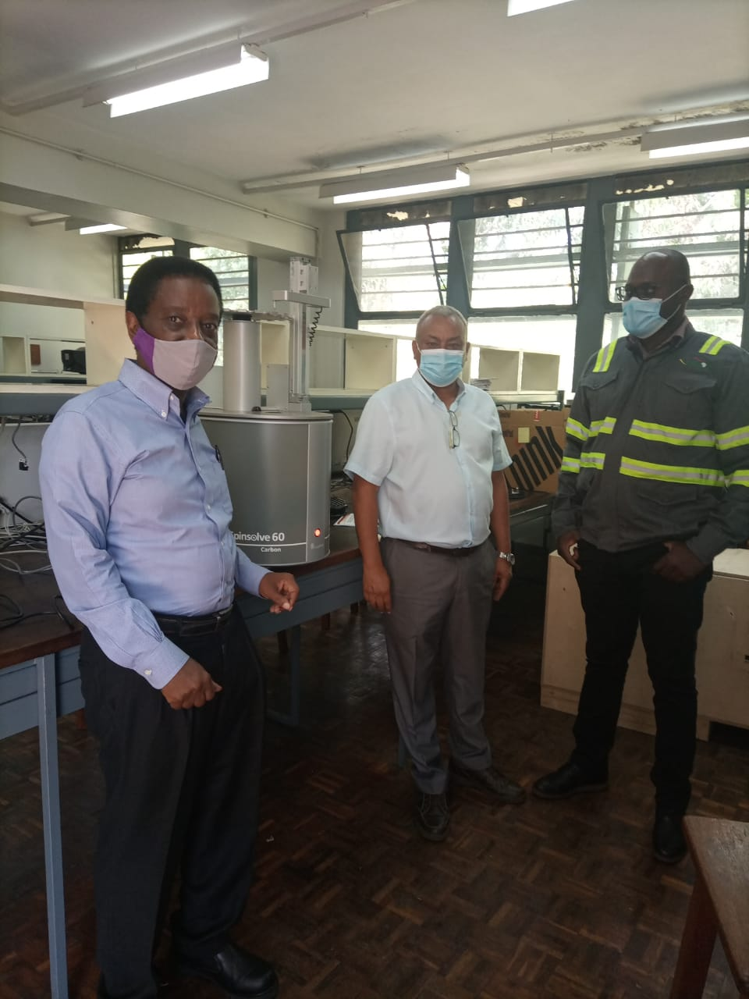

Spin solve 60 NMR, Spectrometer
The National Research Fund – Kenya (NRF-K) has awarded the Department of Chemistry, University of Nairobi KSH 42,796,236 to establish a Kenya National Nuclear Magnetic Resonance (NMR) Centre (KNMRC).The centeris to provide services by analyzing samples using NMR spectrometers for researchers and postgraduate students from various universities and research institution. NMR is the single most important analytical tool for identification of unknown compounds. In this regard, the Department of chemistry has acquired a brand new 60MHz Nuclear Magnetic Resonance Spectrometer (MagritekSpinsolve 60 NMR, Germany) at a cost of KSH 11,072,727.80 from the NRF-K grant and the instrument is already installed, staff trained and is functional. This instrument is capable of analyzing¹H, ¹³C and¹⁹F, both one-dimensional and two-dimensional spectra, which will substantially improve the teaching, research and consultancy capability of the department. We are highly grateful to the National Research Fund – Kenya for the award of the Infrastructure Development Grant, and the University of Nairobi for facilitating and handling of the grant.

The Department also has a Physical Chemistry laboratory with capacity to do various analyses and specialized equipment such as bomb calorimeter, GC, HPLC and Ion Chromatographthat has also increased the scope of analyses. The Department has specialized laboratory for analysis of water, air, natural products, biodiesel and fuels, amongst others samples.

GAS CHROMATOGRAPH MASS SPECTROMETRY (GC/MS) EQUIPMENT

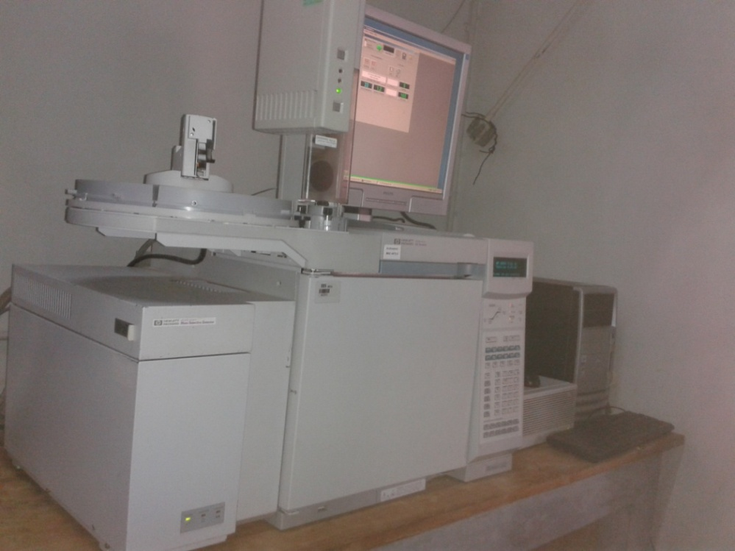

ATOMIC ABSORPTION SPECTROMETER (AAS)
The equipment is important in analysis of heavy metals in environmental samples such as water, soil and sediment; and industrial samples. The AAS is also important in teaching of undergraduate and postgraduate students undertaking units in spectroscopic methods of analysis. It has also been used to support analysis of postgraduate research on heavy metals. The equipment can be used for analysis of heavy metals: Cd, Cu, Pb, Fe, Hg, Mg, Mn, Ni and Zn.

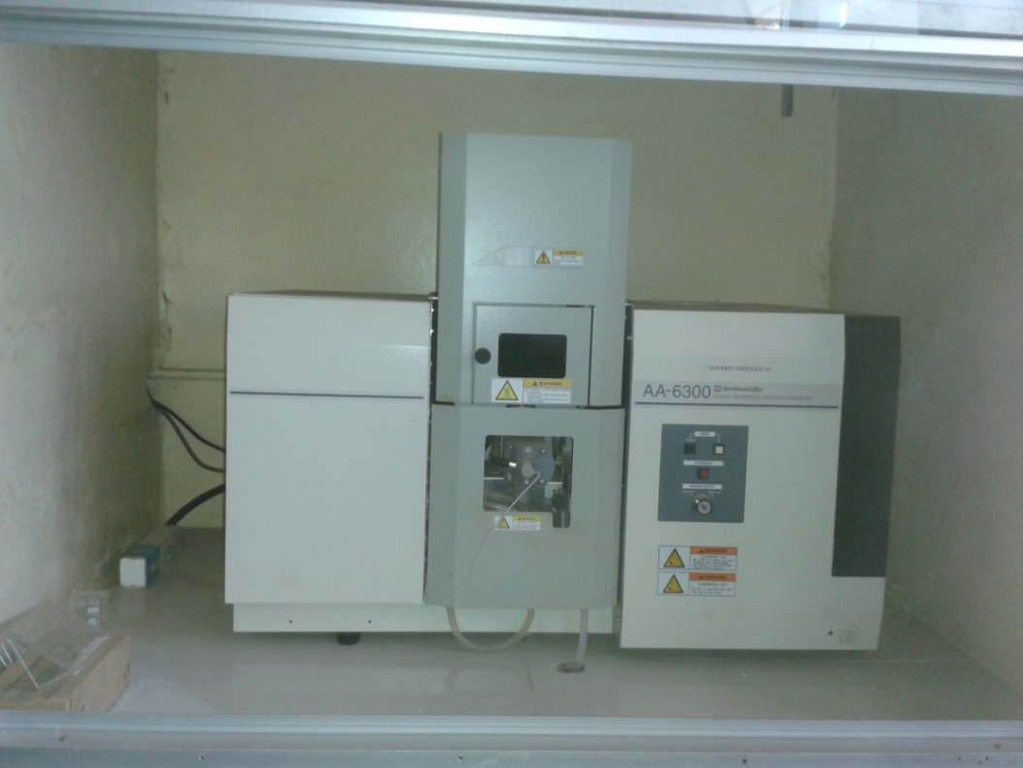
AAS Machine

2.2Research activities
2.2.1 PhD research
Table 2 (Appendices) shows a list of students undertaking PhD projects and their supervisors.

PhD STUDENTS SUPERVISION

S/N | NAME/REG. N0. | TITLE OF PROPOSAL | SUPERVISORS
1 | Moses Oyagi Ondabu  I80/95787/2014 | New Electrochemical Sensor for Selected Heavy Metal Pollutants in Drinking and Wastewaters | Dr. P. Guto  Dr. J. Onyatta  Prof. G. N. Kamau
2 | Nicholas j. Mwenda  I80/9448/2012 | Detoxification of Aflotoxin Contaminated Maize | Prof. S. Wandiga  Prof. D. K. Kariuki  Dr. V. Madadi
3 | Davis Amboga | Biosorption of heavy metal ions from aqueous solutions using macrophytes (Vossia cuspidate and Cyprus papyrus)  (Registered 2013) | Prof. J. Onyari  Dr. A. Salim (JKUAT)  Dr. J. Wambomba
4 | Yoseph Atilaw  I80/92721/2013 | Phytochemical Investigation of Selected Fabaceae and Rutaceae Plants for Anti-inflammatory Principles | Prof. A. Yenesew  Dr. A. Ndakala  Dr. H. Kariuki
5 | Veronica Muinde  I80/92722/2013 | Adsorption of pesticides and organic dyes in water on selected adsorbents and their biodegradation using selected microorganisms | Prof. J. Onyari  Dr. Wamalwa  Dr. Wambomba
6 | Patrick K. Tum | Photocatalytic Treatment of Wastewater from Selected Tea Factories in Kenya | Dr. D. Kariuki  Dr. F. Oduor,  Dr. J. Wanyoko Tea Research Foundation of Kenya Kericho, Kenya
7 | Souaibou Yaouba | Phytochemical Investigation of three Lannea Species for Hepatoprotective Principles | Prof. A. Yenesew  Dr. S. Derese
8 | Florence Masese | Synthesis and Characterization of Titanium (IV) Oxide Nanoparticle Components Composites for Water Purification | Prof. S. Wandiga  Dr. V. Madadi  Dr. D. Mbui
9 | Alfred Maingi | Detection of Melamine and its derivatives in food stuffs sold in Kenya. | Prof. Kamau  Dr. J. Onyatta  Dr. J. Mwaniki
10 | Richard Owor Oriko  I80/501202015 | Phytochemical Investigation of Selected Plants for Control of Maize Weevil | Dr. A Ndakala  Dr. S. Derese  Dr. G. O. Ong’amo  Dr. L. Kerubo
11 | Moses Andima  I80/50060/2016 | Natural Product-loaded Nanoparticles for Cancer Therapy: Synthesis, Characterization, Cellular and Proteomic Studies | Dr. Derese  Dr. Ndakala
12 | Judith Kananu | Modeling soil to tobacco plants’ transfer factor of naturally occuring radioactive elements and heavy metals and efficiency of cigarette filters | Prof. G. N. Kamau  Dr. V. Madadi  Prof. H. Njenga
13
14 | Enock Osoro | Assessment of selected polybrominated diphenyl ethers in nairobi river drainage basin, Kenya and study on their photo catalytic degradation | Prof. Wandiga,  Dr. V. Madadi  Dr. D. Abongo
15 | Gabriel Waswa | Characterization and application of nanozeolites as smart delivery systems for fertilizers and pesticides | Prof. G. N. Kamau  Dr. Andala (Media Univ)  Dr. A. Aluoch (TUK)  Dr. I. Michira (UoN)
16 | James Kamau Mbugua  I80/50383/2016 | Optimization and Design of an Effective Anaerobic Digester for Biogas Production Using Vegetable Wastes from Kenyan Markets | Prof. G. N. Kamau; Dr. J. Mwaniki, Dr. D. Mbui, Prof. F. Mwaura
17 | Fozia Ali Adem  I80/ | Phytochemical analysis of four ormocarpum species for anticancer activity. | Prof. Abiy Yenesew
18 | Fredrick M. Mwazighe | Development of a Nano-alloy and Organic Acid-Doped Polymeric Sensor Platform for Detection of Polycyclic Aromatic Hydrocarbons (PAHS) | Prof. G. N. Kamau  Dr. Njagi Njomo  Prof. L. Njenga
19 | Rachael Njogu | Synthesis and Applications of Tris-Cyclometalated 2-(1-Napthyl) Pyridine Iridium (III) Complexes | Prof. L. Njenga
20 | Mohamed Hussein Omar  I80/50030/2016 | Synthesis of Microporous Clay Silicate Impregnated with Prosopis Juliflora Extracted Lignin Biomaterial Nanocomposites for Removal of Heavy Metals in Water | Dr. Njagi Njomo Prof. A. Yusuf Dr. Immaculate Michira.
21 | Daniel Buyinza  I80/966872014 | Computer Guided Bioprospecting for Antiplasmodial Principles from Cordia Species from Kenya” | Dr. S. Derese Dr. A. Ndakal
22 | Waweru James Gitau  I80/51177/2016 | Development of hexadecylamine capped indium telluride quantum dots sensors for the determination of mammaglobin-a breast cancer marker | Dr. D. Mbui, Dr. Njagi Njomo, Dr. Ajayi (Uo Cape Western Cape, SA), Dr. P. Ndangili (TUK)
23 | Cecilia Wahinga Ndiritu  I80/50991/2016 | Electrochemical and spectroscopic characterization of anti-malarial drug (artemisinin and two derivatives) in aprotic and aqueous micellar solution | Prof. G. N. Kamau  Dr. P. Guto  Dr. J. Mwaniki
24 | Catherine N. Muya  I80/500051/2015 | Optimized Synthetic Design and Characterization of Biodegradable Polymers from Cellulosic Biomass: Grevillia Robusta Leaves as a Potential Economic Output in Plastic Industry | Prof. G. N. Kamau, Prof. L. Njenga, Prof. A. Mugweru
25 | Joshua Sila Munyao | Design and Construction of Polymeric Nanocomposites Based Penicillinase Amperometric Biosensor for Clinical Applications | Prof. G. Kamau  Dr. P. Guto  Dr. I. Michira  Prof. F.B. Mwaura
26 | George Ngang’a Mung’ai  I80/5109/2016 | Geochemical Data of Carbon Dioxide and other Natural gases in Eleven CO₂-rich springs of carbon dioxide, socio-economic and environmental impact of these springs | Prof. G. N. Kamau/Prof. H. Njenga  Prof. L. Njenga  Prof. E. M. Mathu (SEKU)
27 | Antipas Kiprono Kemboi  I80/51896/2017 | Studies on the Oxidative stability of selected unconventional Kenyan oils used in human nutrition | Prof. G. N. Kamau  Dr. H. Rotich (KEBS)  Dr. J. Kithure  Dr. P. Guto
28 | Annah Kerandi Moraa | Determinants of Phthalate esters in human body fluids (urine, saliva, serum and breast milk) of Nairobi and Kajiado County subpopulations | Prof. Shem Wandiga  Prof. W. Mwanda  Dr. V. Madadi  Dr. E. Maina (Dept Biochem)
29 | Immaculate Achieng Odero | The Efficacy of Selected Kenyan Lignocellulosic Materials in the Adsorption of Textile Dyes from Aqueous Industrial Effluents | Prof. P. M. Shiundu Dr. A. O. Aluoch, Dr. B. Wamalwa
30 | Mbugua Simon Ngigi  I80/51491/2017 | Solubility and Kinetic Studies of Substituted Ferrocylimine Pd(ii) and Pt(ii) Complexes for Anticancer Applications | Prof. L. Njenga  Prof. S. Wandiga  Dr. R. Odhiambo  Prof. M. Onani –Western Cape Uni. SA
31 | Annah Kerandi Moraa | Determinants of Phthalate esters in human body fluids (urine, saliva, serum and breast milk) of Nairobi and Kajiado County subpopulations | Prof. Shem Wandiga  Prof. W. Mwanda  Dr. V. Madadi  Dr. E. Maina (Dept Biochem)

2.2.2 MSC Research
MSC 2019/2020 STUDENT - SUPERVISORS
 | Name of student/ Reg. N0. | Supervisors
1 | LANGAT PETER KIPNGENO I56/34910/2019 | - PROF. KITHINJI  - PROF. J, ONYARI
2 | OMONDI VICTOR OCHIENG I56/35025/2019 | - PROF. J. ONYARI  - PROF. F. MULAA  - DR. W. WANYONYI (Kabianga University)
3 | ERICK ONYANGO APUNDA I56/36065/2019 | - PROF. J. ONYARI  - DR. MWAZIGHE  - DR. KIMILU (DEPT OF MECH MANUF. ENG, UoN).
4 | CHOGO SOLOMON INDIAZI I56/35049/2019 | - DR. G. BOSIRE  - PROF. J. ONYARI  - DR. LATTORFF (ICIPE)
5 | ALBERT OMBUI OBARA  I56/30777/2019 | - PROF. L. KERUBO  - DR. J. WANJOHI  - DR. C. KITONDE (SBS- UoN)
6 | OMONDI LEON OWADE I56/34252/2019 | - PROF. L. KERUBO  - PROF. F. MULAA  - DR. W. WANYONYI
7 | PATRICK NDUNG’U MAINA 56/35478/2019 | - DR. P. GUTO  - DR. WAITA (Dept. Physics)
8 | LOISE NDUNGE NJAU  I56/36007/2019 | - DR. P. GUTO  - DR. J. ONYATTA  - DR. I. MICHIRA
9 | SERAH WANJIKU NJOROGE I56/35917/2019 | - DR. I. MICHIRA  - DR. P. GUTO  - DR.D. ABONG’O
10 | DAVID OCHIENG WAMWENDE  I56/ 35893/2019 | - PROF. J. MIDIWO  - DR. S. DERESE
11 | IMWENE KENNEDY OMUKADA I56/35963/2019 | - DR. D. MBUI  - DR. J. ONYATTA
12 | INNOCENT NYAWADE OTIENO I56/35601/2019 | - PROF. D.K. KARIUKI  (Another supervisor to be added)
13 | MUGO WILSON KAMAU I56/33696/2019 | - PROF. D.K. KARIUKI  - DR. J. ONYATTA
14 | CAROLYNE MUENI MUTHUSI I56/33974/2019 | PROF. D. K. KARIUKI  (Another supervisor to be added)
15 | PHOEBE MUMO KYENZE I56/35934/2019 | - DR. D. ABONG’O  - DR. J. ONYATTA  - DR. J. KITHURE
16 | PURITY JAEL OCHIENG I56/35006/2019 | - PROF: A. YENESEW  - DR. A. NDAKALA
17 | DAVID JUMA OKENO I56/36031/2019 | - DR G. BOSIRE  - PROF. D.K. KARIUKI
18 | STEPHEN MUMIRA KIHIKO I56/35989/2019 | - PROF. A. YUSUF  - DR. J. ONYATTA
19 | MICHAEL MWANGI NDIRANGU I56/31383/2019 | - PROF. H. NJENGA  - DR. M. MUKABI
20 | MUIRURI SAMUEL NDUNG’U I56/33768/2019 | - DR. V. MADADI  - PROF. H. NJENGA
21 | VINCENT KIPYATOR KIPTER I56/35238/2019 | - DR. F. WERE  - DR. V. MADADI
22 | STEPHEN NDOLO KIOKO I56/36383/2020 | - DR. V. MADADI  - DR. F. WERE
24 | AARON KIPLANGAT I56/333746/2019 | - DR. J. WABOMBA  - DR. F. MWAZIGHE
25 | JOYCE WANJIKU NYOIKE 156/ 35929/2019 | - DR. J. KITHURE  - DR. D. ABONGO
26 | KIPTOON BENARD YATOR I56/33118/2019 | 1. DR. J. KITHURE  2. DR. D. ABONGO
27 | SAMUEL MUCHOKI MWANGI I56/35912/2019 | - DR. NJAGI NJOMO  - DR. P. TUM  - DR. D. K. KARUKU
28 | WACHIRA MARION NJERI I56/19642/2019 | - DR. N. NJOMO  - DR. D.K. KARUKU (Not from Chemistry)  - DR. P. TUM
29 | OSORE JAMES MWAMBURI I56/35219/2019 | - DR. N. NJOMO  - DR. KAMAU (Not from Chemistry)
30 | CECILIA WANJIKU KAMAU  I56/35944/2019 | - DR. N. NJOMO  - DR.. KARUKU
31 | OTIENO BELETA DIBLI  I56/33747/2019 | - DR G. BOSIRE  - PROF. J. ONYARI  - PROF. MWABORA (Department of Physics)
32 | STACY WAGAKI KIETI I56/35395/2019 | - DR. J. WABOMBA  - PROF. J. ONYARI  - DR. ICHANGI
33 | MARY J. KOSGEY I56/36010/2019 | - DR. F. MWAZIGHE  - DR. P. TUM  - PROF. J. ONYARI
34 | KOECH K. SHADRACK I56/34233/2019 | - DR. N. NJOMO  - DR. P. TUM
35 | MATENA HARDFORCE I56/33395/2019 | - DR. N. NJOMO  - DR. P. TUM
36 | NYUMBA ODHIAMBO DAVID I56/11877/2018 | - DR. N. NJOMO  - DR. P. TUM

2.3INTERNATIONAL LINKS AND COLLABORATIONS
As part of efforts to promote innovation and technology transfer; the Department Linked/Collaborated with the following;
S/No | TITLE | INDUSTRY PARTNERS | DETAILS | DURATION
1 | University industry cooperation anchored on Science, Technology, Engineering and Mathematics. | Memorandum of cooperation between university of Nairobi &MCA group (Manuel Couto Alves group) | UNIVERSITY –industry cooperation anchored on science, technology engineering and mathematics.  The purpose of the cooperation is to enhance the capacity of both institutions’ to fulfil their corporate objectives through educational and industrial engagements. | 5years

2.4 LIST OF RESEARCH PUBLICATIONS 2019

The Department produced the following Journal publications in the year 2020;

SUMMARY OF PUBLICATIONS

S/No. | AUTHOR | TITLE | JOURNAL | MONTH & YEAR
 | Hilda Dinah Kyomuhimbo, Immaculate Nyambura Michira, Francis B Mwaura, Solomon Derese, Usisipho Feleni, Emmanuel I Iwuoha | Silver–zinc oxide nanocomposite antiseptic from the extract of Bidens pilosa | Journal:SN Applied Sciences  Volume: 1  Issue: 7  Pages: 681  Publisher: Springer International Publishing | 1st July 2019

 | Rahab W Kamau, Jacob O Midiwo, Quintino A Mgani, Veronica M Masila, Leonidah K Omosa, Regina N Bwire, Melissa R Jacob, Frank T Wiggers, Ilias Muhammad | Oleanolic Acid and other Compounds Isolated from Cordia africana Lam which Inhibit Vancomycin Resistant Enterococcus. | Journal: Pharmacognosy Communications  Volume: 9  Issue: 3  DOI: 10.5530/pc.2019.3.19 | 1st July 2019
 | Victor Kuete, Leonidah K Omosa, Jacob O Midiwo, Oğuzhan Karaosmanoğlu, Hülya Sivas | Cytotoxicity of naturally occurring phenolics and terpenoids from Kenyan flora towards human carcinoma cells | Journal:Journal of Ayurveda and integrative medicine  Volume:10  Issue:3  Pages: 178-184  https://doi.org/10.1016/j.jaim.2018.04.001 | 1st July 2019
 | R Mogwasi, DK Kariuki, MZ Getenga, V Nischwitz | Comparison of aqueous and enzymatic extraction combination with sequential filtration for the profiling of selected trace elements in medicinal plants from Kenya | Journal: Journal of Trace Elements in Medicine and Biology  Volume: 54  Pages:1-7  Publisher: Urban & Fischer  https://doi.org/10.1016/j.jtemb.2019.03.003 | 1st July 2019
 | P.K Tum | Spectral and Sorption Characteristics of Acid Orange II and Methylene Blue Dyes on TiO2 photocatalyst | Journal  International Journal of Science and Technology  Volume:7  Issue:7  Pages:27-34  DOI No.: 10.24940/theijst/2019/v7/i7/ST1907-023 | July 2019
 | CM Gerrard, JM Wanjohi | Factors influencing the implementation of prisons health projects in Kenya: A case of prisons in Meru region | ©2019 International Academic Journal of Information Sciences and Project Management (IAJISPM) | ISSN 2519-7711  Volume: 3  Issue: 3  Pages: 185-209 | 5th July 2019
 | Ruth Anyango Omole, Mainen Julius Moshi, Matthias Heydenreich, Hamisi Masanja Malebo, Jeremiah Waweru Gathirwa, Richard Owor Oriko, Leonida Kerubo Omosa, Jacob Ogweno Midiwo | Antiplasmodial Biflavanones from the Stem Bark of Garcinia buchananii Engl. | Journal  Pharmacognosy Communications  Volume  9  Issue  3  Pages  96-99  Publisher  EManuscript Services  DOI: 10.5530/pc.2019.3.20. | 1st July 2019
 | Kennedy Olale, Abiy Yenesew, Ramni Jamnadass, Andrew Sila, Keith Shepherd | A simple field based method for rapid wood density estimation for selected tree species in Western Kenya | Journal: Elsevier  Vol. 5  Pages: e00149  https://doi.org/10.1016/j.sciaf.2019.e00149 | 27th Aug 2019
 | Hiram Kirimi, John Wanjohi | Factors Influencing Use Of Alternative Dispute Resolution In Construction Projects: Case Of Imenti North Sub County, Meru County | International Academic Journal of Information Sciences and Project Management | Volume 3, Issue 4, pp. 572-602 | 9th Aug 2019
 | Majau, D. K. & Wanjohi, J. | Factors Influencing Employee Job Performance In County Government Departmental Projects: A Case Of Meru County Government, Kenya | International Academic Journal of Information Sciences and Project Management  Volume 3, Issue 4, pp. 518-543 518 | 6th Aug 2019
 | Mary Njenga, Nancy Karanja, Jacob Kithinji, Ramni Jamnadaa, Miyuki Iiyama, Aya Yonemitsu | Evaluating Fuel Briquette Technologies and their Implications on Greenhouse Gases and Livelihoods in Kenya | Publisher  World Agroforestry-Research Data Repository  https://doi.org/10.34725/DVN/HTPFRS, World Agroforestry - Research Data Repository, V1 | 6th Aug 2019
 | Daniel Buyinza, Li Jun Yang, Solomon Derese, Albert Ndakala, Paolo Coghi, Matthias Heydenreich, Vincent Kam Wai Wong, Heiko M Möller, Abiy Yenesew | Cytotoxicity of isoflavones from Millettia dura | Journal  Natural Product Research  Pages  1-4  Publisher  Taylor & Francis  https://doi.org/10.1080/14786419.2019.1660335 | 5th Sept 2019
 | Fozia A Adem, Victor Kuete, Armelle T Mbaveng, Matthias Heydenreich, Andreas Koch, Albert Ndakala, Beatrice Irungu, Abiy Yenesew, Thomas Efferth | Cytotoxic flavonoids from two Lonchocarpus species | Journal: Natural product research  Volume: 33  Issue: 18  Pages: 2609-2617  Publisher: Taylor & Francis  https://doi.org/10.1080/14786419.2018.1462179 | 17th Sept 2019
 | R Mogwasi, DK Kariuki, ZM Getenga | Effect of Farm Additives on the Potential Bioavailability of Some Nutritional Elements from Kenyan Wild Plants | Journal  Biological trace element research  Pages  1-11  Publisher  Springer US  https://doi.org/10.1007/s12011-019-01855-8 | 10th Sept 2019
 | Harry Amuguni Chanzu, John Mmari Onyari, Paul Mwanza Shiundu | Brewers’ spent grain in adsorption of aqueous Congo Red and malachite Green dyes: Batch and continuous flow systems | Journal: Journal of hazardous materials  Volume: 380  Pages: 120897  Publisher: Elsevier  https://doi.org/10.1016/j.jhazmat.2019.120897 | 15th Dec 2019
 | JM Mwaniki, JO Onyatta, AO Yusuf | Adsorption of Heavy Metal Ions from Aqueous Solutions and Wastewater using Water Hyacinth Powder | Journal: International Journal of Trend in Scientific Research and Development (IJTSRD)  Volume: 4  Issue:1 | Dec 2019
 | Veronica M Masila, Albert J Ndakala, Robert Byamukama, Jacob O Midiwo, Rahab W Kamau, Mei Wang, Mallika Kumarihamy, Jianping Zhao, Matthias Heydreich, Ilias Muhammad | Synthesis, structural assignments and antiinfective activities of 3-O-benzyl-carvotacetone and 3-hydroxy-2-isopropyl-5-methyl-p-benzoquinone | Journal  Natural Product Research  Pages  1-9  hSttps://doi.org/10.1080/14786419.2020.1716346 | 27th Jan 2020
 | Kiplangat Rop, Damaris Mbui, George N Karuku, Immaculate Michira, Njagi Njomo | Characterization of water hyacinth cellulose-g-poly (ammonium acrylate-co-acrylic acid)/nano-hydroxyapatite polymer hydrogel composite for potential agricultural application | Journal  Results in Chemistry  Volume  2  Pages  100020  Publisher  Elsevier  https://doi.org/10.1016/j.rechem.2019.100020 | 1st Jan 2020
 | Ruth Anyango Omole, Mainen Julius Moshi, Muhammad Ilias, Walker Larry, Hamisi M Malebo, Leonida Kerubo Omosa, Jacob O Midiwo | In vitro Antiplasmodial and Cytotoxic activity of Three Medicinal Plants used Traditionally for Treatment of Malaria. | Journal  Pharmacognosy Communications  Volume  10  Issue  1  DOI:10.5530/pc.2020.1.2 | 1st Jan 2020
 | Moses Andima, Paolo Coghi, Li Jun Yang, Vincent Kam Wai Wong, Chrispus Mutuku Ngule, Matthias Heydenreich, Albert Jairo Ndakala, Abiy Yenesew, Solomon Derese | Antiproliferative Activity of Secondary Metabolites from Zanthoxylum zanthoxyloides Lam: In vitro and in silico Studies. | Journal  Pharmacognosy Communications  Volume  10  Issue  1  DOI: 10.5530/pc.2020.1.8 | 1st Jan 2020
 | Patrick Kimutai Tum, David K Kariuki | Photocatalytic Degradation of 4-Chlorophenol by Titanium Dioxide: Role of Annealing Temperature and Morphology | Journal  International Journal of Innovative Research and Development  Volume  8  Issue  11  Pages  235-244 | 14th Feb 2020
 | Valerie Bauza, Vincent Madadi, Robinson Ocharo, Thanh H Nguyen, Jeremy S Guest | Enteric pathogens from water, hands, surface, soil, drainage ditch, and stream exposure points in a low-income neighborhood of Nairobi, Kenya | Journal  Science of The Total Environment  Volume  709  Pages  135344  Publisher  Elsevier  https://doi.org/10.1016/j.scitotenv.2019.135344 | 20th March 2020
 | Richard Oriko Owor, Kibrom Gebreheiwot Bedane, Yolande Ikala Openda, Sebastian Zühlke, Solomon Derese, George Ong’amo, Albert Ndakala, Michael Spiteller | Synergistic anti-inflammatory activities of a new flavone and other flavonoids from Tephrosia hildebrandtii vatke | Journal  Natural Product Research  Pages  1-8  Publisher  Taylor & Fran  https://doi.org/10.1080/14786419.2020.1736065 | 31st March 2020
 | Richard Oriko Owor, Kibrom Gebreheiwot Bedane, Sebastian Zühlke, Solomon Derese, George Otieno Ong’amo, Albert Ndakala, Michael Spiteller | Anti-inflammatory Flavanones and Flavones from Tephrosia linearis | Source  Journal of Natural Products  Publisher  American Chemical Society and American Society of Pharmacognosy  https://doi.org/10.1021/acs.jnatprod.9b00922 | 10th March 2020
 | Vaderament-A Nchiozem-Ngnitedem, Leonidah Kerubo Omosa, Solomon Derese, Pierre Tane, Matthias Heydenreich, Michael Spiteller, Ean-Jeong Seo, Thomas Efferth | Two new flavonoids from Dracaena usambarensis Engl. | Journal: Phytochemistry Letters  Volume: 36  Pages:80-85  https://doi.org/10.1016/j.phytol.2020.01.001 | 1st April 2020
 | Emily B Chebet, Joshua K Kibet, Damaris Mbui | The assessment of water quality in river Molo water basin, Kenya | Journal: Applied Water Science  Volume:10  Issue:4  Pages:1-10 | April 2020
 | Olivia Osiro, Bernina Kisumbi, David Kariuki, Loice Gathece | Implications of the Minamata Convention on Mercury on Oral Health in Kenya | Journal: Kenya Policy Briefs  Volume: 1  Issue: 1  Pages: 17-18 | 26th APRIL 2020
 | Chrispine M Oloo, John M Onyari, Wycliffe C Wanyonyi, John N Wabomba, Veronica M | Adsorptive removal of hazardous crystal violet dye form aqueous solution using Rhizophora mucronata stem-barks: Equilibrium and kinetics studies | Journal  Environmental Chemistry and Ecotoxicology  Publisher  Elsevier  https://doi.org/10.1016/j.enceco.2020.05.001 | 8th May 2020

2.5 CONSULTANCIES/RESEARCH PROJECTS

 | Funder | Project | Principal Investigator/Project leader | Amount (currency) | Duration | comments
2 | Bill gates | Zeolite hydrogel nano-mop for contraception | Dr. Benson Wamalwa | US Dollars 100,000 | 01/05/2010-30/11/2021 | Active
4 | Grand challenges Canada | Saving lives at birth a loyally program |  | USD 331383 | 01/01/2016-31/12/2018 | Active
5 | Grand challenge Canada | Bar codes for improved child vaccination and famine nutrition |  | USD 113000 | 23/03/2012-01/04/2014 | Active
6 | IDRI | Infectious diseases research | Prof. Jacob Midiwo |  | 10/05/2011 | Active
7 | Uppsala university | Ken02 chemistry |  | Sek 2,881,975 | 01/01/2011-31/12/2017
8 | National Research Fund (NRF) | Xploring Kenya Biodiversity Chemistry, Phamacology and Commercialization |  | Euro 44,000 | 01/04/17-31/05/2018 | Active
9 | GEF-NPIF (Kenya Wildlife Service) | Developing the microbial biotechnology industry from soda lakes in Kenya | Prof. L. Kerubo | USD 440,000 | 31/08/2017 | Active
10 | ICIPE | Promoting small holder access to fungal bio pesticides through public private partnership in East Africa |  | USD 54,758 | 01/03/2018 – 30/12/2021 | Active
11 | The welcome trust | Cement dust exposure and related effects in Kenya | Dr. Faridah Were | KES400,000 | 13/10/2017 | Active
12 | Uppsala University | Capacity building for PhD students | Prof. Lydia Njenga | SEK 101,760 | 9/02/2016-31/05/2016 | Active

2.6. The virtual 64th Graduation Ceremony
The University of Nairobi 63rd Graduation ceremony Department of Chemistry making his speech.
2.6.1. The Table below shows the number of students per program graduated in Sept. 2020
Academic Year | BSc in chemistry | BSc Industrial Chemistry | BSc Analytical Chemistry | MSc In Chemistry | MSc Indstrial Chem | MSc Environmental Chemistry | MSc. Analytical chem | Ph.D in Chemistry | Total
2019/2020 | 35 | 45 | 17 | 3 | 2 | 1 | 3 | 2 | 108

2.6.2Postgraduate Students graduated in September 2020
Master of Science in Analytical Chemistry
- Moenga, David Nyamweya
- Mungai, James
- Oloo, Sebastian Otieno
Master of Science in Chemistry
- KHISA, Jackline Nangila
- OBONGO, Rael Akoth Kasera.
- OLOO, Chrispine Moses Oder
Master of Science in Environmental Chemistry
- Kundu, Bevin Nabai

Master of Science in Industrial Chemistry
- Mwakazi, Eva Dama.
- Ochieng, Sharon Alice Okuku

Doctor of Philosophy Degree in Chemistry
- Andima, Moses
- Buyinza, Daniel
2.6.3. Number of Bsc Graduands in Various Programs, December 20, 2020
The Table below shows the number of students graduated in 2019 per program.
Year | BSc in Chemistry | BSc Industrial Chemistry | BSc Analytical Chemistry | MSc In Chemistry | Msc Analytical | MSc Environmental Chemistry | MSc INDUSTRIAL CHEMISTY | Ph.D in Chemistry | Total
2019/2020 | 2 | 2 | 4 | 2 | 1 | 1 | 1 | 3 | 16

2.6.4 Postgraduate Students graduated, Dec 2020 per program.
1. Master of Science in Environmental Chemistry
chilikwazi bright
2. Master of Science in Chemistry
Ochiba, Nancy Khayongo
Msc analytical
Bernard isaiah
4. PHD students
- Mbugua,Simon Ngigi .
- Njogu,Rachael E. Njeri .
- Waswa,Gabriel Andati

2.7Papers Presented at Conferences
S/N | CONFERENCE | THEME | Paper presented | DATE
1 | Expert consultative meeting for sustainable global monitoring of POPs under the Stockholm convention | Expert consultative meeting for sustainable global monitoring of POPs under the Stockholm convention | Cytotoxic flavonoids from two Lonchocarpus species by Fozia Ali Adem | 12th Feb 2019
2 | Pan Africa Chemistry Network Congress 2019 | Riches of the Natural world: sustainable use of Africa’s natural products and materials | Cytotoxity of plumbagin, rapanone and 12 other naturally occurring quiniones from Kenyan flora towards human carcinoma cells presented by Prof. Leonidah Omosa Kerubo | 5th-7th Nov 2019, Addis Ababa
3 | Pan Africa Chemistry Network Congress 2019 | Riches of the Natural world: sustainable use of Africa’s natural products and materials | The Kenyan higher plant diversity: a source of anti-parasitic compounds for neglected tropical diseases presented by Prof. Jacob Midiwo | 5th-7th Nov 2019, Addis Ababa
4 | Pan Africa Chemistry Network Congress 2019 | Riches of the Natural world: sustainable use of Africa’s natural products and materials | Red hot compounds from the Red hot poker plant, Kniphofia, and related taxa presented by Prof. Abiy Yenesew | 5th-7th Nov 2019, Addis Ababa
5 | Pan Africa Chemistry Network Congress 2019 | Riches of the Natural world: sustainable use of Africa’s natural products and materials | Anti-vancomycin-resistant Enterococcus faecum and E.Faecalis activities of (-)-Gossypol and Derivative from Thespecia garckeana | 5th-7th Nov 2019, Addis Ababa
6 | Pan Africa Chemistry Network Congress 2019 | Riches of the Natural world: sustainable use of Africa’s natural products and materials | Rotenoids from East African Plants-Structure, Stereochemistry and Biological Activity | 5th-7th Nov 2019, Addis Ababa
7+ | Royal Society of Chemistry | 14th International Conference on Materials Chemistry (MC14) | Ruthenium (II) Oxathia Crown Ether Complexes: synthesis, Characterization and their Application in the Detection of Mercury (II) Ions’ | 8th-11th July 2019

EBE STAFF AS PI ON ACTIVE GRANT EBE STAFF AS PI ON ACTIVE GRANT
S/N | VOTE | TITLE | AMOUNT | CORDINATOR | DOCUMENTATION
 | 500653378 | To Establish NMR Centre of Excellence | 42,796,236.00 | Prof. John Onyari | Receipt and Statement from the Grants Office
 | 500661862 | Strategic Partnership For Higher Education | 2,669,437.652 | Prof. John Onyari | Statement from Grants office
 | 500661797 | Promoting Smallholder Access to Fungal Biopesticides | 120,000 | Prof Leonida Kerubo | Statement from Grants office
 | 500661347 | PAN African Chemistry Network | 509,986.500 | Professor Midiwo | Statement from Grants office
 | 500661739 | Kenya GMP2 POPS Project | 1,645,045,490 |  | Statement from Grants office

2.8. Programmes Engaging Guest Lecturers/Speakers
S/No | GUEST LECTURER/SPEAKERS | PROGRAMME | DETAILS | DATE
 | Dr. Wanyonyi, Wycliffe | Project Management | Part-Time lecturer | 11th January 2019
 | Prof. Dr. Dr. h.c Michael | Chemical Interactions of Plant-microbes | Chemical Interactions of Plant-microbes | 1st April 2019
 | Dr Cecil Kingondu | Seminar | Specific Capacitance-pore Texture Relationship of Biogas Slurry Mesoporus Carbon/ MnO2 composite Electrodes for supercapacitors. | 10th April 2019
 | Dr, Agnieszka Wegrzyn | Synthesis, characterization and application of new materials obtained from natural and synthetic layered minerals in environmentally friendly adsorption and catalytic processes | Synthesis, characterization and application of new materials obtained from natural and synthetic layered minerals in environmentally friendly adsorption and catalytic processes presented by Dr, Agnieszkka Wegrzyn, Jagiellonian University in Krakkow, Faculty of Chemistry | 3rd July 2019
 | Prof Fulgentius Nelson Lugemwa | Organic Chemistry | Visiting Professor from Pennslyvannia State University-York, US | 1st Sep 2019

FOURTH YEAR PROJECT ORAL EXAMINATION FOR CLASS 2020
WEDNESDAY 18TH JUNE 2020 VIRTUAL DEFENSE ON “GOOGLE MEET”
07.45-08:00 am: Opening Remarks: Chairman, Department of Chemistry

Session 1: CO-CHAIRS: DR. PETERSON GUTO/DR. G. BOSIRE

Time |  | Registration Number | Name | Project Title |  | Main Session Examiners
08:00-08:20 |  | I64/5189/2017 | Mumbua  Josephine  Mutisya | Isolation and Characterization of Anticancer Compounds from the Leaves of Aspilia pluriseta |  | Prof. J. Onyari  Prof. J.P. Kithinji  Prof. A. Yenesew  Prof. L. Kerubo  Dr. G. Bosire  Dr. J. Mwaniki  Dr. S. Derese  Dr. A. Ndakala  Dr. N. Njagi  Dr. R. Odhiambo  Dr. J. Onyatta
08:20-08:40 |  | I08/1437/2017 | Christine Achieng Otieno | Synthesis and characterization of zeolite x for use in industrial application
08:40-09:00 |  | I64/5184/2017 | Kavayi Kenneth Munyoike | Phytochemical investigation of the root bark extract of dracaena usambarensis for anticancer principles
09:00-09:20 |  | I64/5355/2014 | Linzy Chepkorir Sigey | Assessment of red soil in adsorption of fluoride from an aqueous solution
09.20-09:40 |  | I64/2074/2017 | Mostune Mary Obuya | Phytochemical investigation of aerial part of pentas bussei for antileishmanial activity
09:40-10:00 |  | I64/5218/2018 | Ekesa Elizabeth Sarah | Phytochemical investigation of stem bark of pentas parvifolia for anticancer principles
10:00-10:20 |  | I64/5202/2017 | Shekina Ruth Lumumba | Phytochemical studies of Macaranga conglomerata for anticancer principles
11:00-13:20 Tea Break
Session 2: CO-CHAIRS: Mr. C. MIRIKAU/DR.VINCENT MADADI
Time |  | Registration Number | Name | Project Title |  |  |  | Main Session Examiners
11:00-11:20 |  | I64/5422 /2016 | Cornelius Wanyonyi | Phytochemical Investigation of Millettia usaramensis for Anticancer Principles |  |  |  | Prof. J. Midiwo  Prof. R. Munavu  Prof. H. Njenga  Dr. V. Madadi  Ms. R. Njogu  Dr. B. Wamalwa  Mr. C. Mirikau  Dr. D. Mbui  Dr. W. Odinga  Mr. J. Makopa  Prof. A. Yusuf  Prof. L. Njenga  Dr. J. Wabomba  Mr. G. Wafula  Ms. I. Adero  Dr. D. Abong’o  Dr. J. Wanjohi  Dr. F.D.O Oduor
11:20-11:40 |  | I64/5201/2017 | Chantal Antoinette Aloo | Determination of sodium and toxic metals in sea salts in Nairobi, Kenya
11:40-12:00 |  | I64/5546/2016 | Jackline Okello | Determination of levels of selected heavy metals in soil in parts of industrial area in Nairobi County, Kenya
12:00-12:20 |  | I64/1592/2016 | Kimani Mbuthia | Remote sensing air quality monitor
12:20-12:40 |  | I64/2082/2016 | Peter Absolom Njoroge | Phytochemical investigation of Fagaropsis angolensis for anticancer principles
12:40-13:00 |  | I08/44386/2017 | Meeme Michelle Kendi | A study on efficiency and emission characteristics of the aleurites moluccanus (candlenut) seeds as a biofuel
13:00– 13:20 |  | I64/5181/2017 | James Njoroge Munyui | The effect of environmental exposure on the lead levels in borehole water consumed in nairobi
14:00-15:00 Lunch
Session 3: CO-CHAIRS: DR. J. WABOMBA /DR. M. MUKABI
14:00-14:20 | I08/1452/2017 |  | Lawrence Oduor Ouma |  | Phytochemical investigation of gnidia apiculata for antiplasmodial principles |  | Prof. D. Kariuki  Prof. J. Midiwo  Dr. S. Derese
14:20-14:40 | I08/43524/2017 |  | Tracey Njoroge |  | In silico studies for anti-inflammatory activity of tephrosia linearis
14:40-15:00 | I14/14427/2017 |  | Patra  Nyabate |  | Comparative study of paracetamol 500 mg tablets from local manufacturers

3.0 Performance Contract
The Performance contract between the School of Physical Sciences Management Board and Department of Chemistry for the period 1st July 2020and 30th June 20201 was signed on 1st July2021. The Performance matrix was circulated to all staff. It will be measured by its success in meeting or surpassing the performance targets set out in the Performance matrix..

THE 8TH NATIONAL LEAD POISONING PREVENTION WEEK OF ACTION 29TH OCTOBER 2020
  - Sub-Regional Lead Poisoning Prevention Week Of Action Campaigns To Ban Import, Export And Use Of Lead Paint Across The East Africa Region Held Online On 29th October 2020.

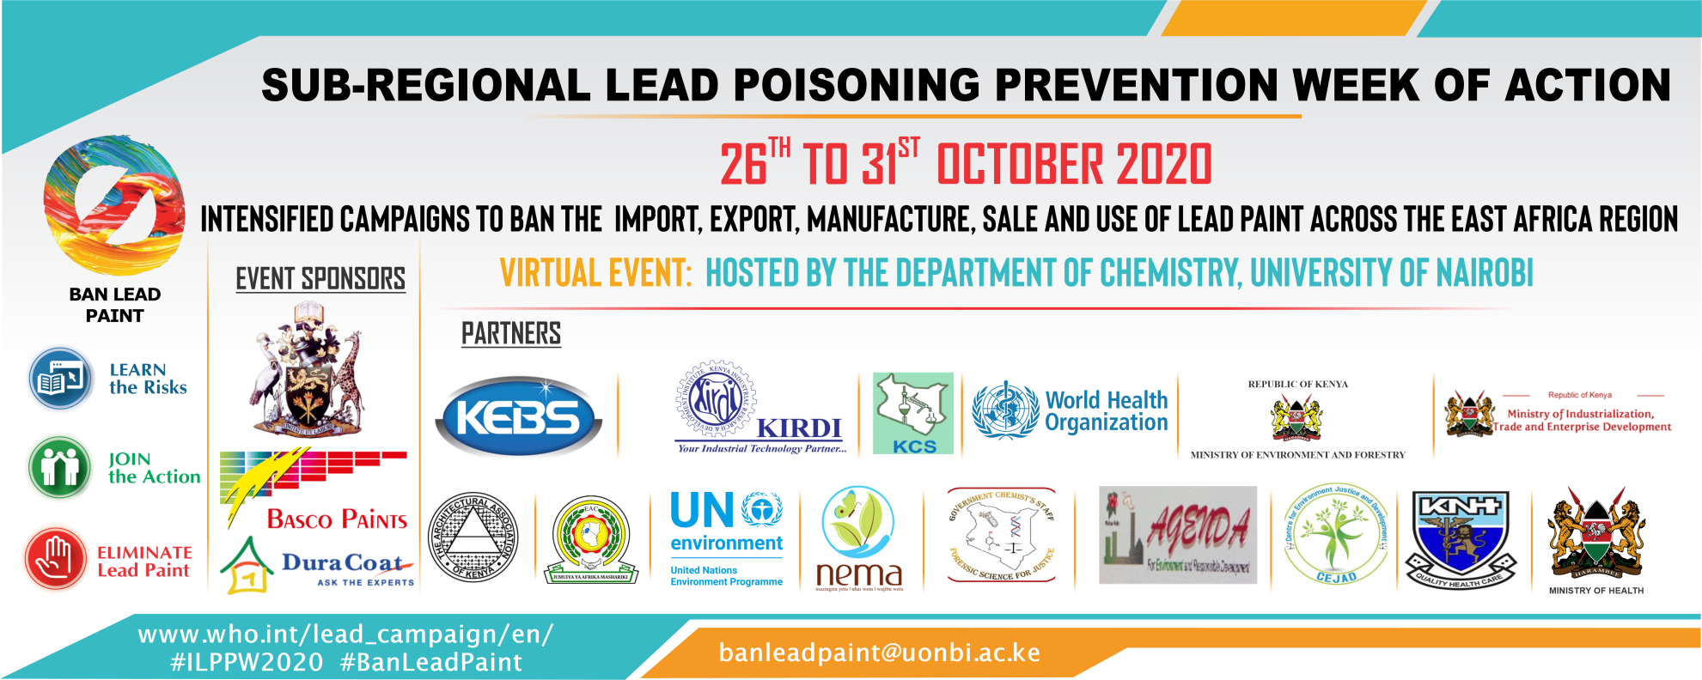

The aim of International Lead Poisoning Prevention Week is to draw attention to the health impacts of lead exposure, highlight efforts by countries and partners to prevent childhood lead exposure, and accelerate efforts to phase out the use of lead in paint.
The sub-regional Event sponsors are University of Nairobi, Basco Paints, Dura Coat and the partners in this campaign includes; KEBS, The Architectural Association of Kenya, UNEP, KIRDI, NEMA, Ministry of Environment & Forestry, Ministry Health, World Health Organization and many other Partners.

UON-BASF Chiroklean Liquid Soap Hand Wash Distribution To The University Of Nairobi Community

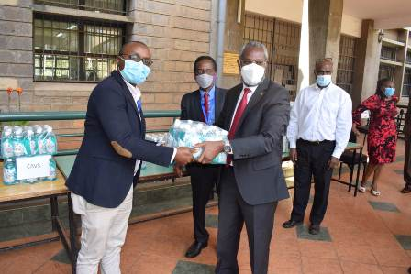
The University of Nairobi, Department of Chemistry in collaboration with BASF Company distributed Chiroklean Hand wash to the University of Nairobi community.
The event was graced with the presence of the UoN Vice Chancellor, Prof. Stephen Kiama.
Please click the link below to see the Vice Chancellor's speech during the ceremony

3.5. Staff members who travelled outside Kenya In 2019
Academic Staff
- Prof. Abiy Yenesew, PACN CONFERENCE IN Addis Ababa
- Dr. Solomon Derese, PACN Conference, Addis, Ethiopia
- Chemistry Staff Team Building

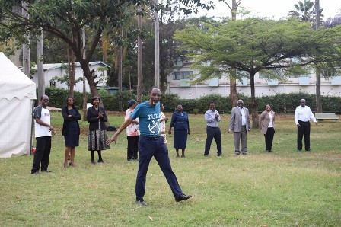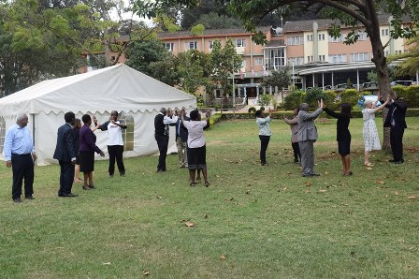

3.8. Corporate Social Responsibility/Outreach Services

- Faridah Hussein Were: Chairlady, Technical Committee for the East Africa Standard for Paints and Allied Products & Member of Advisory Council of Lead Alliance Partner.
- Prof. D. K Kariuki, External Examiner, University of Zambia & University of Malawi, Harzadious & Toxic Matyerials Committee member, NEMA, Threshold Pollution in Waste Water Committee, WARMA.
- Dr. Wanjohi John: External Examiner; Kenyatta University.
4. Dr. Derese, Solomon: External Examiner; Masinde Muliro & Karatina University.

3.9 Other Activities

3.9.2. Conference/workshop/symposium
The Department organized the following events;
- Revised chemistry undergraduate programs: Bachelor Of Science Chemistry, Bachelor of Industrial Chemistry and Bachelor of Analytical Chemistry.
- Launch of Uon-Basf Chiroklean Liquid Soap Hand Wash

Challenges
- Delay in postgraduate students in completion of thesis.
- Procurement process (EPMIS) –delay in procuring and delivery of lab materials.
- Virtual teaching challenges against face to face

